📘 DBMS Cheat Sheet – Join Algorithms

🔹 1. Iteration (Nested Loop) Join
- Idea: For each tuple in R, scan S for matches.
- Cost (naïve, non-contiguous):
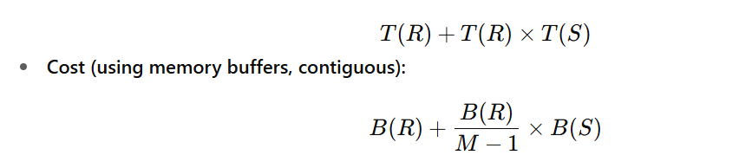
where M = available buffers.
- Optimizations:
  - Use multiple buffers to hold chunks of R.
  - Choose smaller relation as outer loop.
  - With 2 buffers only → still possible, but very costly.

🔹 2. Merge Join
- Idea: Works if both R and S are sorted on join attribute.
- Cost (if sorted already):
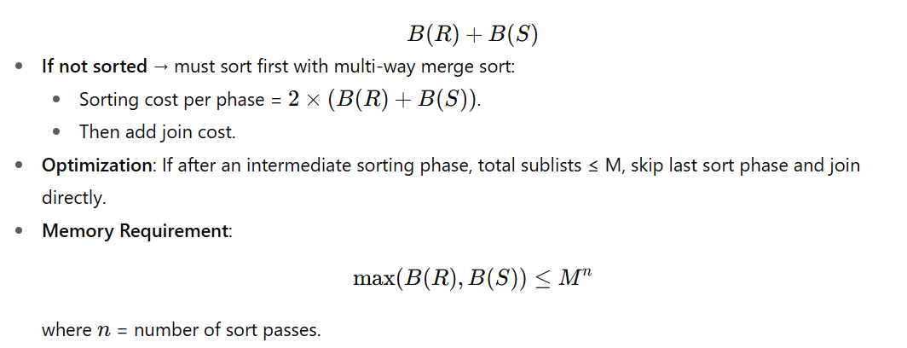

🔹 3. Hash Join
- Idea: Partition both R & S into buckets using hash function on join attribute, then only compare matching buckets.
- Cost (2-phase hash join, contiguous):
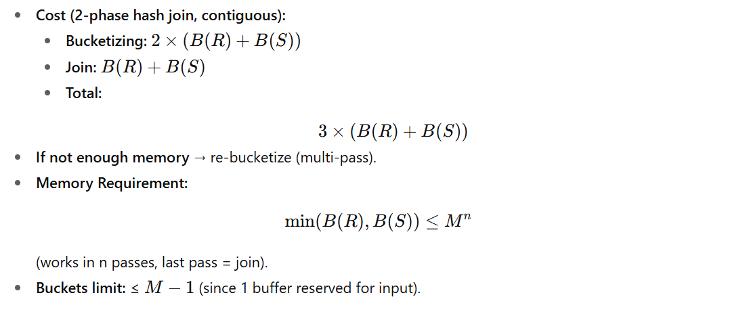

🔹 4. One-Pass Join

